# Configure Billing Rates

# Document Overview

Billing rates determine the premiums charged for different coverage tiers under a specific benefit plan. When a new benefit plan is attached to an account (group), either when a new account is loaded or at the time of renewal, billing rate configuration is required for the account or any associated subscriptions to be billed under that benefit plan. This document provides instructions for creating and editing billing rates in HealthRules Manager (HRM).

# Process:

**Access the Benefit Plan**

1. In HRM, click the search  button for account on the members card.   
    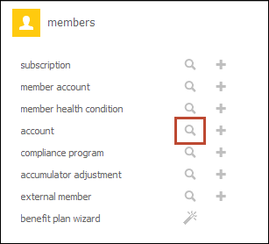
2. Enter search criteria to locate the associated account.
3. Click **Search**.
4. Double-click the applicable account in the results list. The account record appears.
5. If the account is a risk account (pool or experience rated), select the applicable sub account at the top of the screen. If the account is an ASC account, select the applicable sub-sub account.
6. Click the **Benefit Plans** tab.

To set up billing rates for a benefit plan that doesn’t yet have any defined, continue to the Configure New Billing Rates section below. To edit existing billing rates, continue to the Edit Billing Rates section below.

**Configure New Billing Rates**

Follow these instructions to create billing rates for a benefit plan that does not yet have any billing rates defined.

1. From the Benefit Plans tab of the appropriate sub account or sub-sub account, click **Create Billing Rates** to the right of the appropriate benefit plan.   
   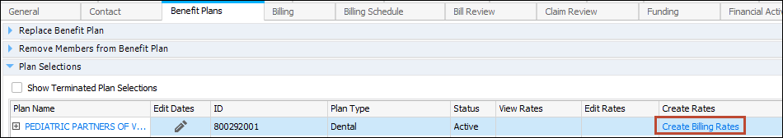
2. Click **Add** to the right of the **Billing Category Rates** header.  
    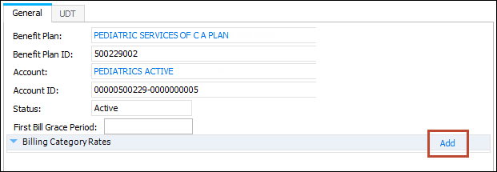
3. Expand the **Billing Category Rate** section.  
   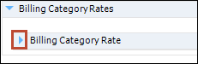
4. Enter information according to the table below. Any fields not included in the table should not be populated.

|  |  |  |  |  |
| --- | --- | --- | --- | --- |
| **Field** | **Description** | **Required** | **Optional** | **Comments** |
| Billing Category | The billing category from which the bill originated. | X |  | For risk-free groups, select Premium. For ASC groups, select ASC Fee - Flat. |
| Calculation Method | Indicates how the billed amount is calculated. | X |  | For Risk accounts (both pool and experience rated), select Wash. For ASC accounts, select Full Period. |
| Min. Enrolled Days | Indicates how many days a subscription must be enrolled during a month in order for it to be billed. | X |  | Applies only to ASC accounts. Enter a value of 1. |
| Billing Party | Indicates whether the account or subscription should be billed. | X |  | Set this field to Account. Exception: when setting up billing rates for individually billed benefit plans, set this field to Subscription. |
| Billing Percentage | Indicates the percent billed to the party chosen in previous field. | X |  | Enter a value of 100.00 (100%). |
| Rate Category | Indicates the Rate Category, such as Community Rated or Experience  Rated. | X |  | For experience rated groups, select Experience Rated. For pool rated groups, select Community Rated. |
| Rate Sub-Category | Indicates the Rate Sub-Category, such as Fixed, Prospective, or  Retrospective. | X |  | Set this field to Fixed Rate. |
| Type | Indicates the type of billing rate that is being charged. | X |  | Set this field to Per Subscription Per Month. |
| Default Rate | Enter the default base rate amount. | X |  | Enter a value of $0.00. |

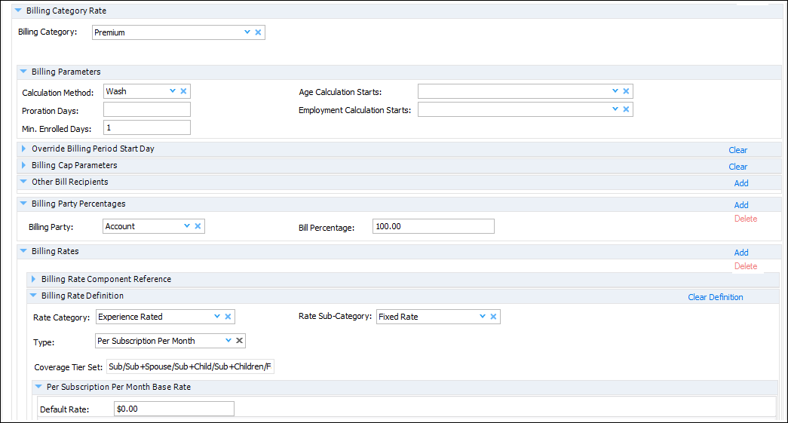

1. Under the *Default Rate*, select the *Set specific rates for age, gender, and/or coverage tier* option.
2. In the **Specific Rates** section, click the plus  sign under **Add Row**.  
   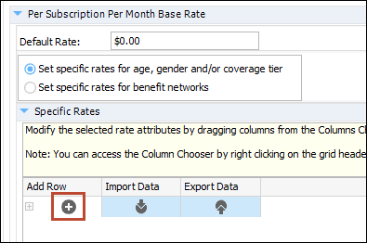
3. In the **Coverage Tier** field, choose a coverage tier.
4. In the **Amount** field, enter the bill amount for the chosen coverage tier. This should match the premium entered on the New Account Sheet (NAS) or group application. ASC accounts include a fee for each coverage tier on the form.
5. Repeat steps 6-8 for all coverage tiers listed below.  
   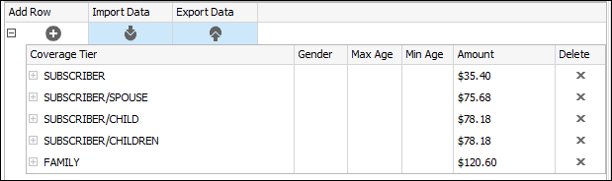
6. Click **Save**.
7. In the **Reason Code** field, ensure **New Configuration** is selected.
8. Enter comments in the **Comment** field.  
   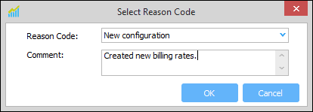
9. Click **OK**.

**Edit Billing Rates**

Follow these instructions to edit billing rates that have already been defined for a benefit plan.

1. From the Benefit Plans tab of the appropriate sub account or sub-sub account, click **Edit Billing Rates** to the right of the appropriate benefit plan. The Specify As of Date window appears.  
     
   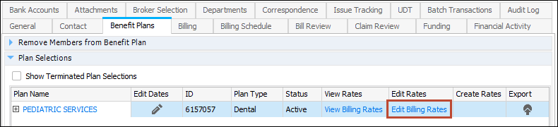
2. To edit the initial version of this benefit plan, ensure **Use Initial Version** is selected. To make this change effective starting at a certain date, such as a renewal period, select **Specify As of Date** and enter a date.  
     
   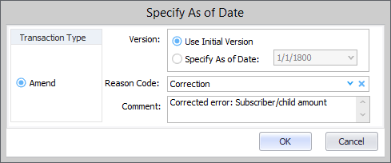
3. Select the reason for this change in the **Reason Code** field and enter any comments in the **Comments** field. If you don’t complete these fields, you will be prompted to do so when you save your changes.
4. Click OK. The Edit Billing Rate window opens.
5. Make the necessary edits. For field-by-field guidance, refer to the Configure New Billing Rates section above.
6. Click **Save**.

**View Billing Rates**

Follow these instructions to view billing rates that have already been defined for a benefit plan.

1. From the Benefit Plans tab of the appropriate sub account or sub-sub account, click *View Billing Rates* to the right of the appropriate benefit plan. The billing rate configuration opens.  
     
   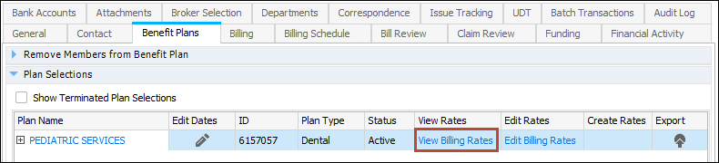
2. Expand the Per Subscription Per Month section to see details, such as the amount specified for each coverage tier.

## Related Documentation with Link:

BPD – Configuring Billing Rates

Refer to the Glossary of Terms for clarification of terms used in this document.